Muhammad Furqan Abaid  
**18F0374**Section 7C

SMD – **Google Map Task**

**Final Output**

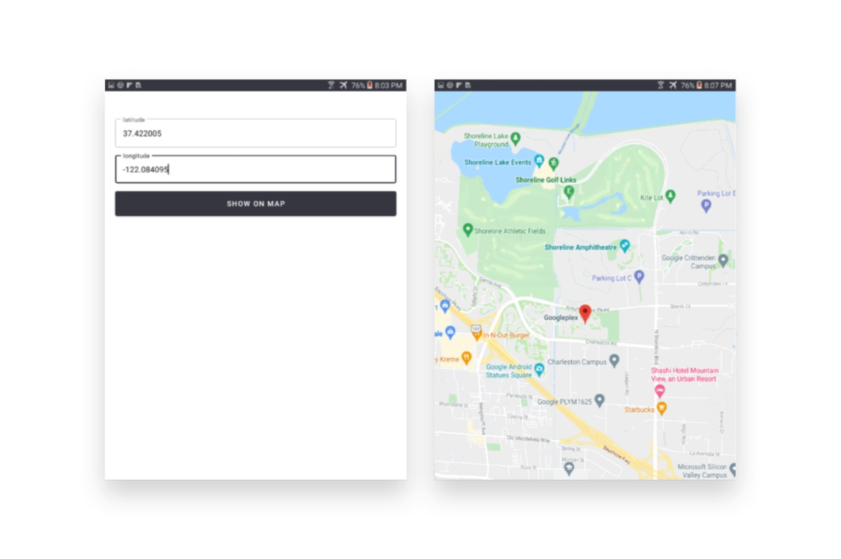

**GoogleMapLatLongMainActivity.java**

package com.example.lab02.GoogleMap1;  
  
import androidx.appcompat.app.AppCompatActivity;  
  
import android.content.Context;  
import android.content.Intent;  
import android.os.Bundle;  
import android.text.Editable;  
import android.util.Log;  
import android.view.View;  
import android.widget.EditText;  
import android.widget.Toast;  
  
import com.example.lab02.R;  
import com.google.android.material.textfield.TextInputEditText;  
import com.google.android.material.textfield.TextInputLayout;  
  
public class GoogleMapLatLongMainActivity extends AppCompatActivity {  
 TextInputLayout lati,longi;  
 TextInputEditText latitude,longitude;  
  
 *//EditText longitude= new TextInputEditText(textInputLayout.getContext());* @Override  
 protected void onCreate(Bundle savedInstanceState) {  
 super.onCreate(savedInstanceState);  
 getSupportActionBar().hide();  
 setContentView(R.layout.*activity_google_map_lat_long_main*);  
 lati=findViewById(R.id.*latitude*);  
 longi=findViewById(R.id.*longitude*);  
 }  
 public void showOnMap(View view) {  
 String lat=lati.getEditText().getText().toString();  
 String lon=longi.getEditText().getText().toString();  
 Intent intent=new Intent(this,Google_Map_1MapsActivity.class);  
 intent.putExtra("lat",Float.*valueOf*(lat));  
 intent.putExtra("lon",Float.*valueOf*(lon));  
 startActivity(intent);  
 }  
}

**Google_Map_1MapsActivity.java**

package com.example.lab02.GoogleMap1;  
  
import androidx.annotation.NonNull;  
import androidx.core.app.ActivityCompat;  
import androidx.core.content.ContextCompat;  
import androidx.fragment.app.FragmentActivity;  
import androidx.fragment.app.FragmentManager;  
  
import android.Manifest;  
import android.annotation.SuppressLint;  
import android.content.Context;  
import android.content.Intent;  
import android.content.pm.PackageManager;  
import android.location.Location;  
import android.location.LocationListener;  
import android.location.LocationManager;  
import android.os.Bundle;  
import android.util.Log;  
import android.widget.Toast;  
  
import com.example.lab02.R;  
import com.example.lab02.databinding.ActivityGoogleMap1MapsBinding;  
import com.google.android.gms.maps.CameraUpdate;  
import com.google.android.gms.maps.CameraUpdateFactory;  
import com.google.android.gms.maps.GoogleMap;  
import com.google.android.gms.maps.OnMapReadyCallback;  
import com.google.android.gms.maps.SupportMapFragment;  
import com.google.android.gms.maps.model.LatLng;  
import com.google.android.gms.maps.model.MarkerOptions;  
  
public class Google_Map_1MapsActivity extends FragmentActivity implements OnMapReadyCallback {  
  
 private GoogleMap mMap;  
 private ActivityGoogleMap1MapsBinding binding;  
 LocationManager locationManager;  
 LocationListener locationListener;  
 @SuppressLint("ServiceCast")  
 @Override  
 protected void onCreate(Bundle savedInstanceState) {  
 super.onCreate(savedInstanceState);  
  
 binding = ActivityGoogleMap1MapsBinding.*inflate*(getLayoutInflater());  
 setContentView(binding.getRoot());  
 locationManager = (LocationManager) getSystemService(Context.*LOCATION_SERVICE*);  
 locationListener =new LocationListener() {  
 @Override  
 public void onLocationChanged(@NonNull Location location) {  
  
 }  
 @Override  
 public void onProviderEnabled(@NonNull String provider) {  
 }  
  
 @Override  
 public void onProviderDisabled(@NonNull String provider) {  
 }  
 };  
 if(ContextCompat.*checkSelfPermission*(this, Manifest.permission.*ACCESS_FINE_LOCATION*)!= PackageManager.*PERMISSION_GRANTED*){  
 ActivityCompat.*requestPermissions*(this,new String[]{Manifest.permission.*ACCESS_FINE_LOCATION*},1);  
 }  
 else{  
 locationManager.requestLocationUpdates(LocationManager.*GPS_PROVIDER*,0,0,locationListener);  
 }  
 *// Obtain the SupportMapFragment and get notified when the map is ready to be used.* SupportMapFragment mapFragment = (SupportMapFragment) getSupportFragmentManager()  
 .findFragmentById(R.id.*map*);  
 mapFragment.getMapAsync(this);  
 }  
  
 @Override  
 public void onRequestPermissionsResult(int requestCode, @NonNull String[] permissions, @NonNull int[] grantResults) {  
 super.onRequestPermissionsResult(requestCode, permissions, grantResults);  
 if(requestCode==1){  
 if(grantResults.length>1 && grantResults[0]==PackageManager.*PERMISSION_GRANTED*){  
 if(ContextCompat.*checkSelfPermission*(this,Manifest.permission.*ACCESS_FINE_LOCATION*)==PackageManager.*PERMISSION_GRANTED*){  
 locationManager.requestLocationUpdates(LocationManager.*GPS_PROVIDER*,0,0,locationListener);  
 }  
 }  
 }  
 }  
@Override  
 public void onMapReady(GoogleMap googleMap) {  
 mMap = googleMap;  
 mMap.setMapType(GoogleMap.*MAP_TYPE_NORMAL*);  
 *//Bundle bundle=getIntent().getExtras();* Intent intent=getIntent();  
 Float latitude=intent.getFloatExtra("lat",0);  
 Float longitude=intent.getFloatExtra("lon",0);  
 *// Add a marker in Sydney and move the camera* LatLng mp = new LatLng(latitude,longitude);  
 mMap.addMarker(new MarkerOptions().position(mp).title(""));  
 mMap.moveCamera(CameraUpdateFactory.*newLatLng*(mp));  
 CameraUpdate cameraUpdate = CameraUpdateFactory.*newLatLngZoom*(mp, 15);  
 mMap.animateCamera(cameraUpdate);  
 }  
  
}

**activity_google_map_lat_long_main.xml**

*<?*xml version="1.0" encoding="utf-8"*?>*<LinearLayout xmlns:android="http://schemas.android.com/apk/res/android"  
 xmlns:app="http://schemas.android.com/apk/res-auto"  
 xmlns:tools="http://schemas.android.com/tools"  
 android:layout_width="match_parent"  
 android:orientation="vertical"  
 android:layout_height="match_parent"  
 tools:context=".GoogleMap1.GoogleMapLatLongMainActivity">  
 <com.google.android.material.textfield.TextInputLayout  
 android:id="@+id/latitude"  
 android:layout_width="match_parent"  
 android:layout_height="wrap_content"  
 android:hint="@string/Latitude"  
 android:layout_marginHorizontal="20dp"  
 android:layout_marginTop="50dp"  
 android:layout_marginBottom="5dp"  
 style="@style/Widget.MaterialComponents.TextInputLayout.OutlinedBox">  
 <com.google.android.material.textfield.TextInputEditText  
 android:layout_width="match_parent"  
 android:layout_height="wrap_content"  
 android:inputType="numberSigned|numberDecimal"  
 android:maxLines="1"  
 />  
 </com.google.android.material.textfield.TextInputLayout>  
 <com.google.android.material.textfield.TextInputLayout  
 android:id="@+id/longitude"  
 android:layout_width="match_parent"  
 android:layout_height="wrap_content"  
 android:layout_marginVertical="5dp"  
 android:hint="@string/longitude"  
 android:layout_marginHorizontal="20dp"  
 style="@style/Widget.MaterialComponents.TextInputLayout.OutlinedBox">  
 <com.google.android.material.textfield.TextInputEditText  
 android:layout_width="match_parent"  
 android:layout_height="wrap_content"  
 android:inputType="numberSigned|numberDecimal"  
 android:maxLines="1"  
 />  
 </com.google.android.material.textfield.TextInputLayout>  
 <Button  
 android:id="@+id/showOnMap"  
 android:onClick="showOnMap"  
 android:layout_width="match_parent"  
 android:layout_height="60dp"  
 android:layout_marginVertical="5dp"  
 android:layout_marginHorizontal="20sp"  
 style="@style/Widget.MaterialComponents.Button"  
 android:text="Show on Map">  
  
 </Button>  
</LinearLayout>

**Design of xml**

**Thank you!**